Install nodejs
Install visual studio code
Create Playwright folder and open it from visual studio code.
Run npm command to install playwright

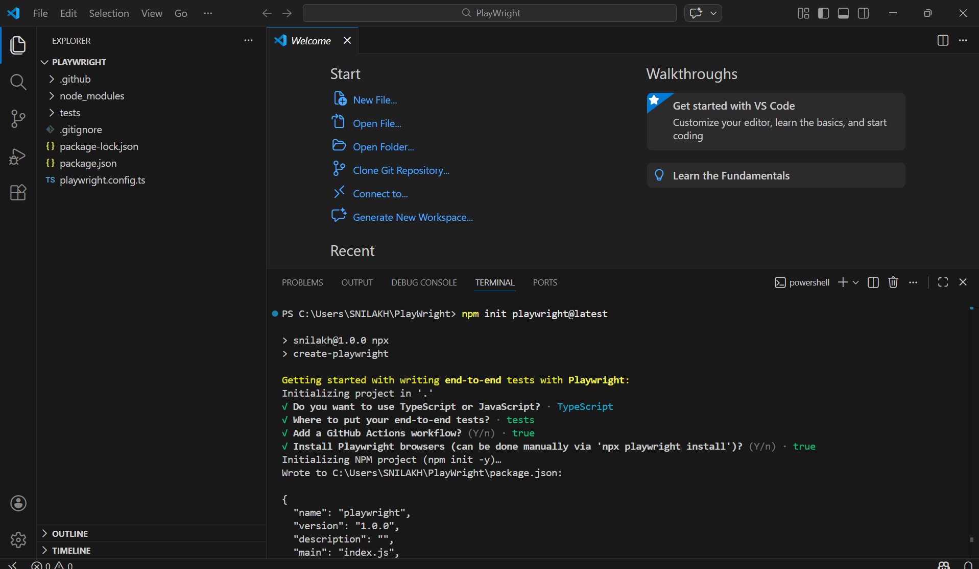

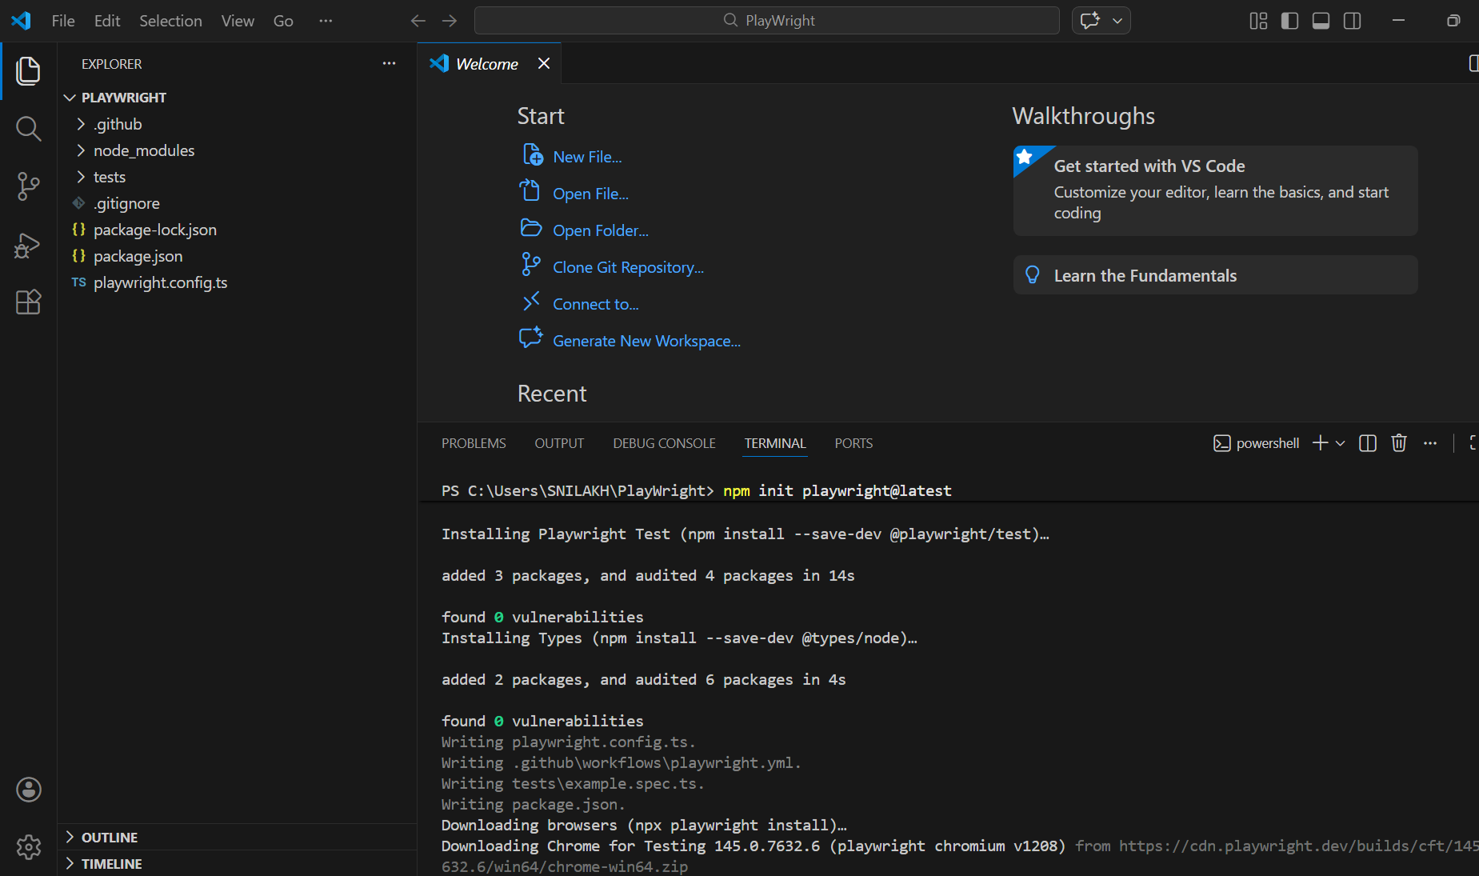

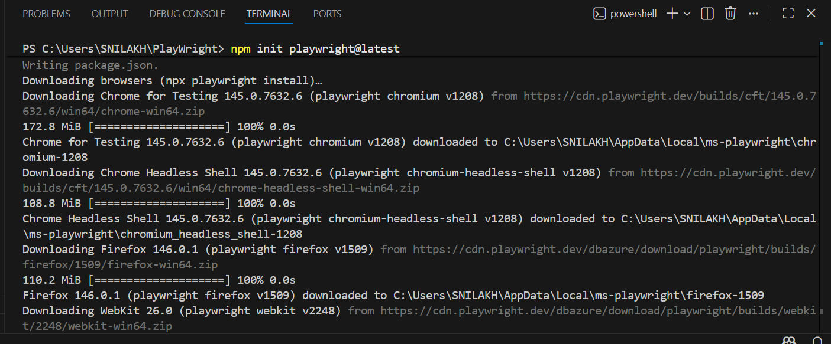

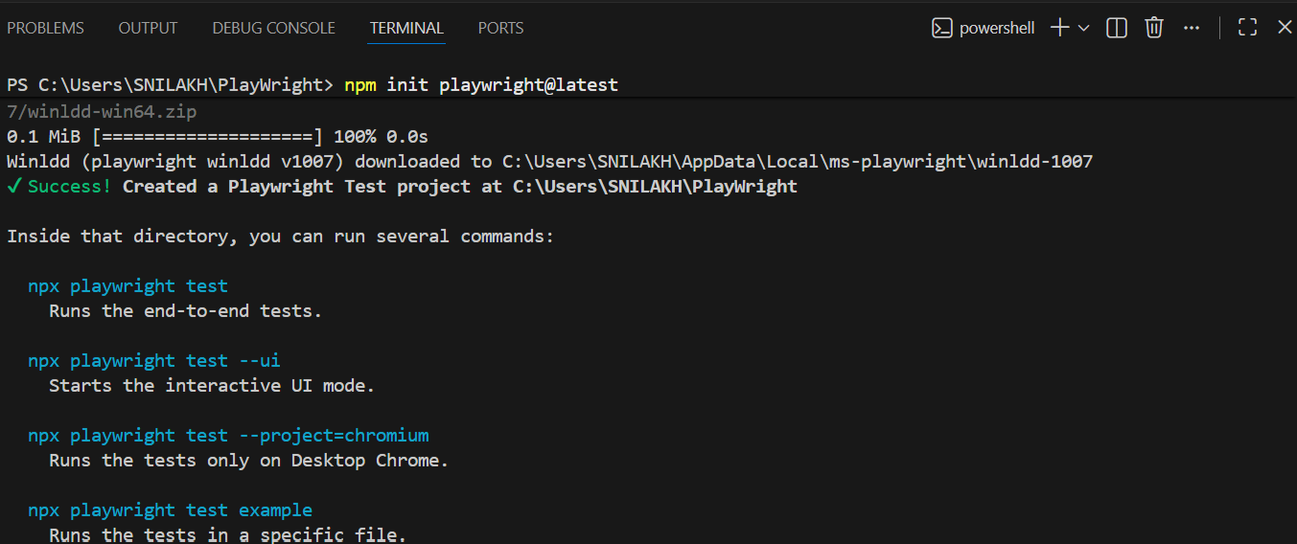

To run test:
npx playwright test this runs in headless mode i.e. without opening up browser visually.

If you want to run it with browser visually visible: [If you don’t mention browser, it runs on all the browsers mentioned in playwright.config.ts. Eg. Chrome, Safari, Firefox]
npx playwright test --headed

Run test on a specific browser: [webkit- Safari browser]
npx playwright test --headed --project chromium

Run a particular class only:
npx playwright test landing-page.spec.ts –headed

Run tests in Ui mode [time travel debugging mode]: for debugging and detailing purpose. Best way
npx playwright test –ui
success:
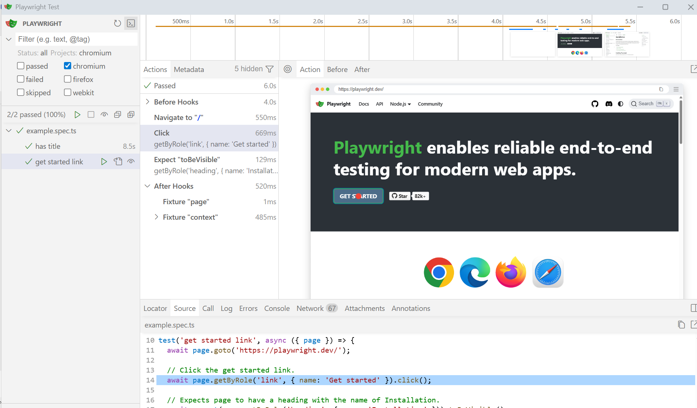

Failure:
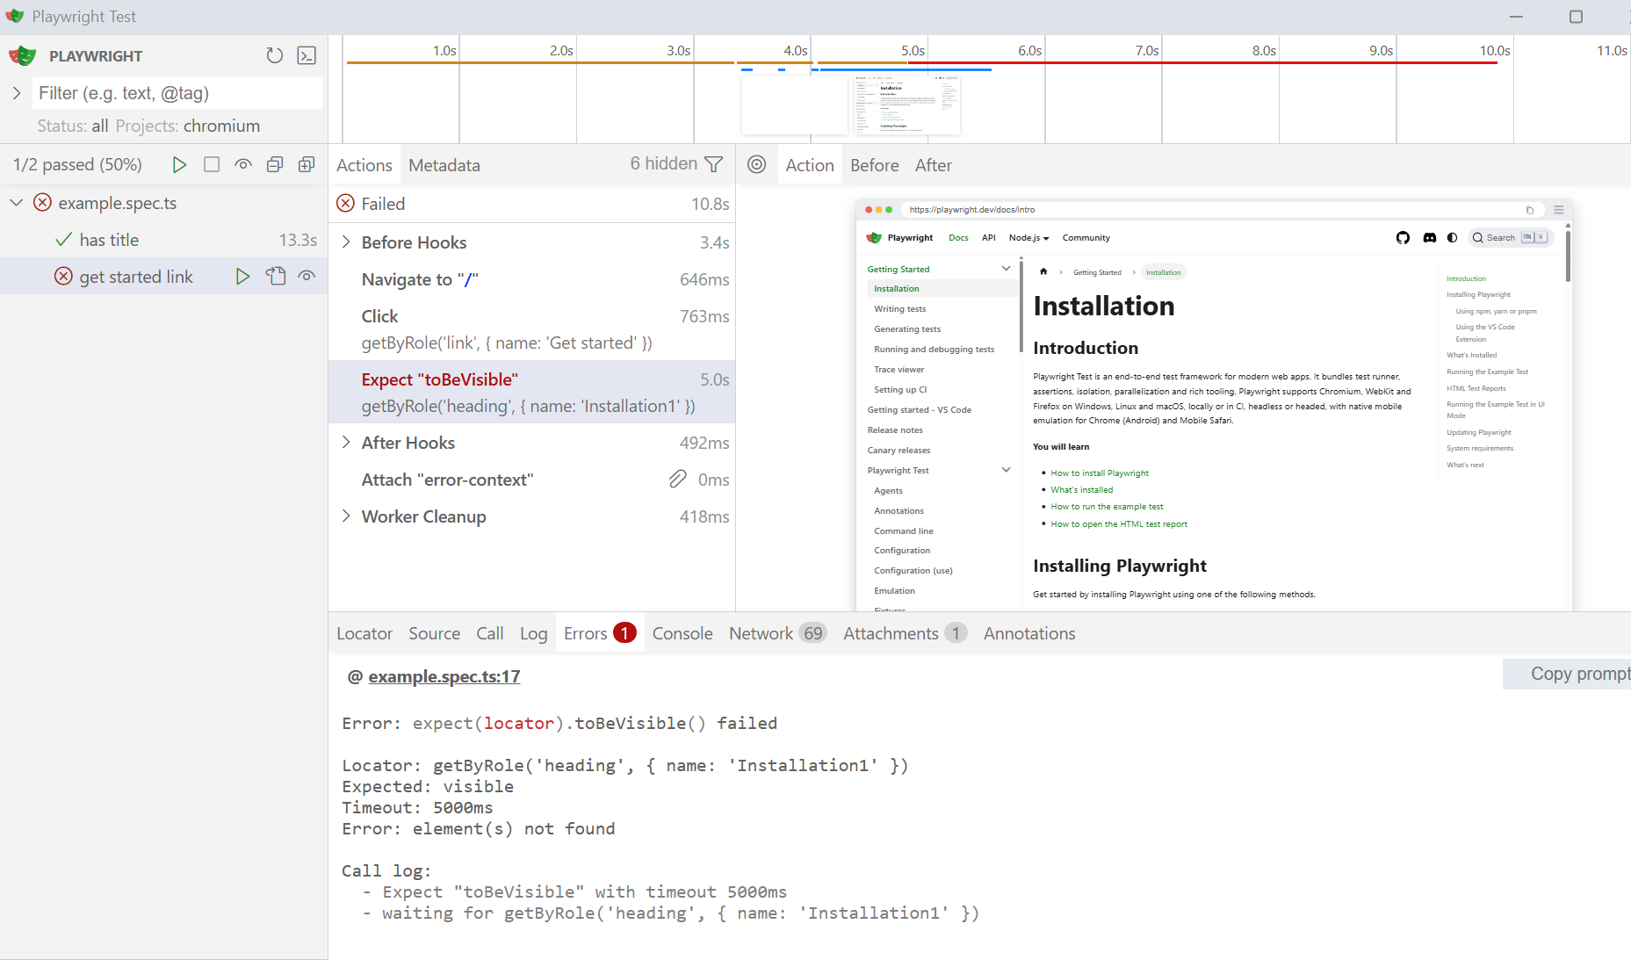

to view html report:
npx playwright show-report
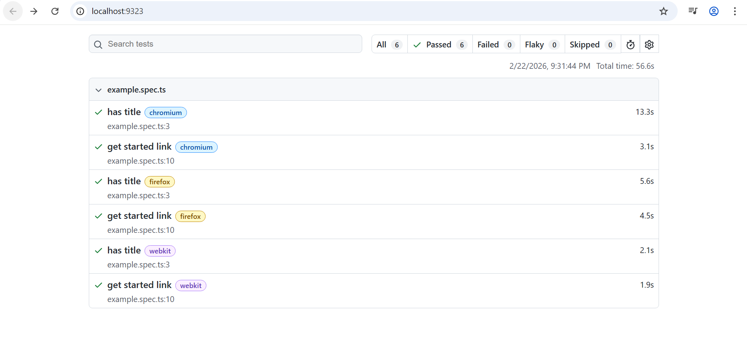

package.json == pom.xml
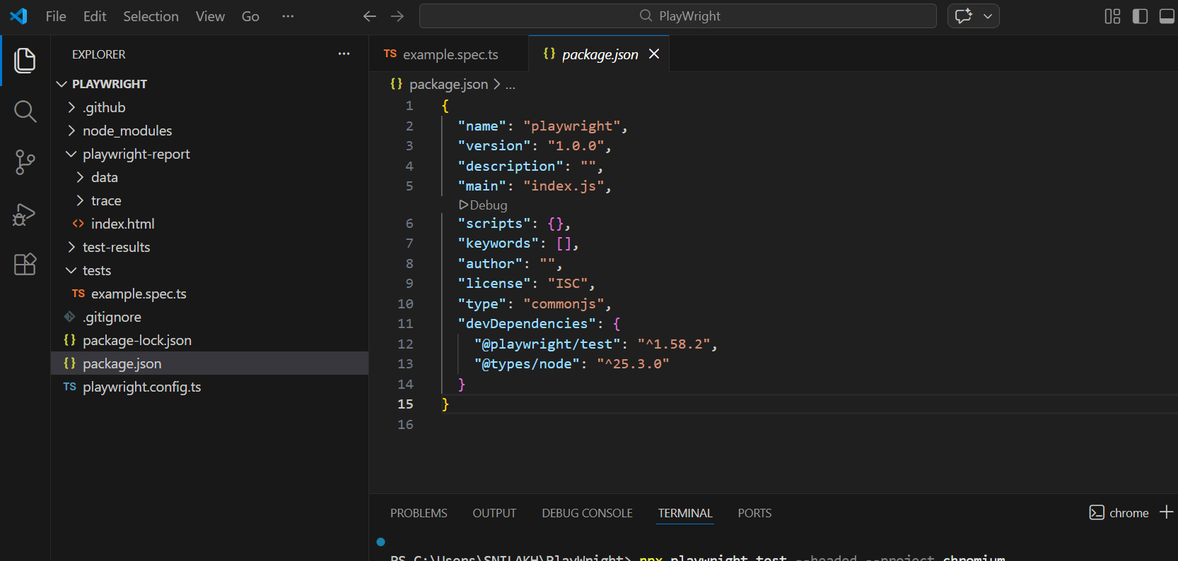

For writing tests, we need to have playwright, playwright/tests, typescript installed.
Commands to install those from terminal if you don’t have it and want to add in package.json file. If already present and you run command, it will take latest available version and will replace it.
npm install playwright --save-dev installing playwright
npm install @playwright/test --save-dev installing playwright/test
npm install typescript --save-dev installing typescript

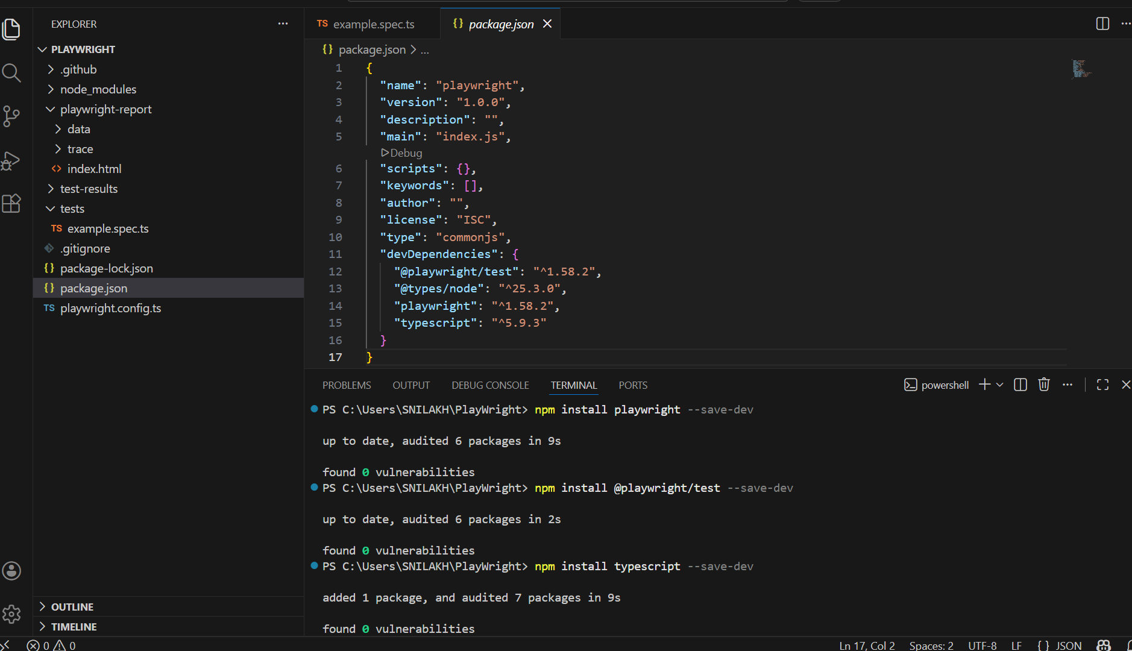

Now we need to initialize typescript:
npx tsc --init
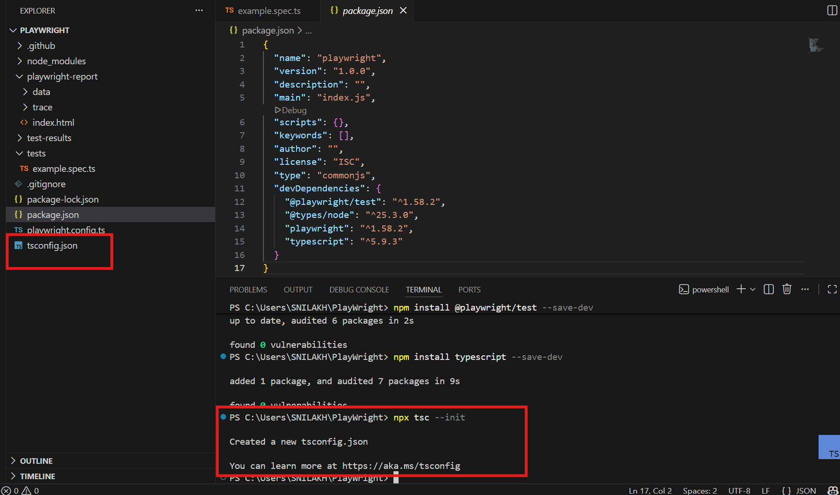

Modify target and module in tsconfig.json:
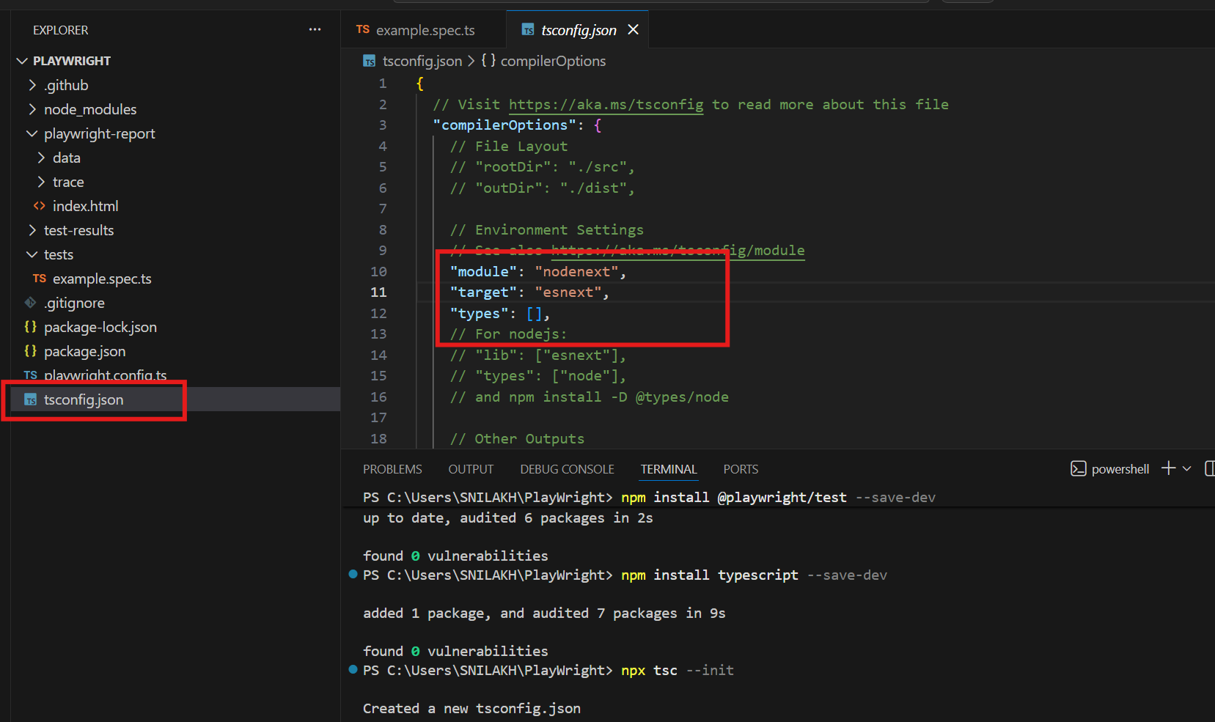

Target: Specify which JavaScript language features are used in the output code. Possible values: ES3 (default), ES5, ES2015/ES6, ESNext, etc.
Module: Controls the syntax used for imports and exports in the output code. Possible values: None, CommonJS, AMD, System, UMD, ES6/ES2015, ESNext, NodeNext, etc.
Change values to: Target- ES6, Module- commonjs

Now playwright test runner extension needs to be added for running and debugging test cases.
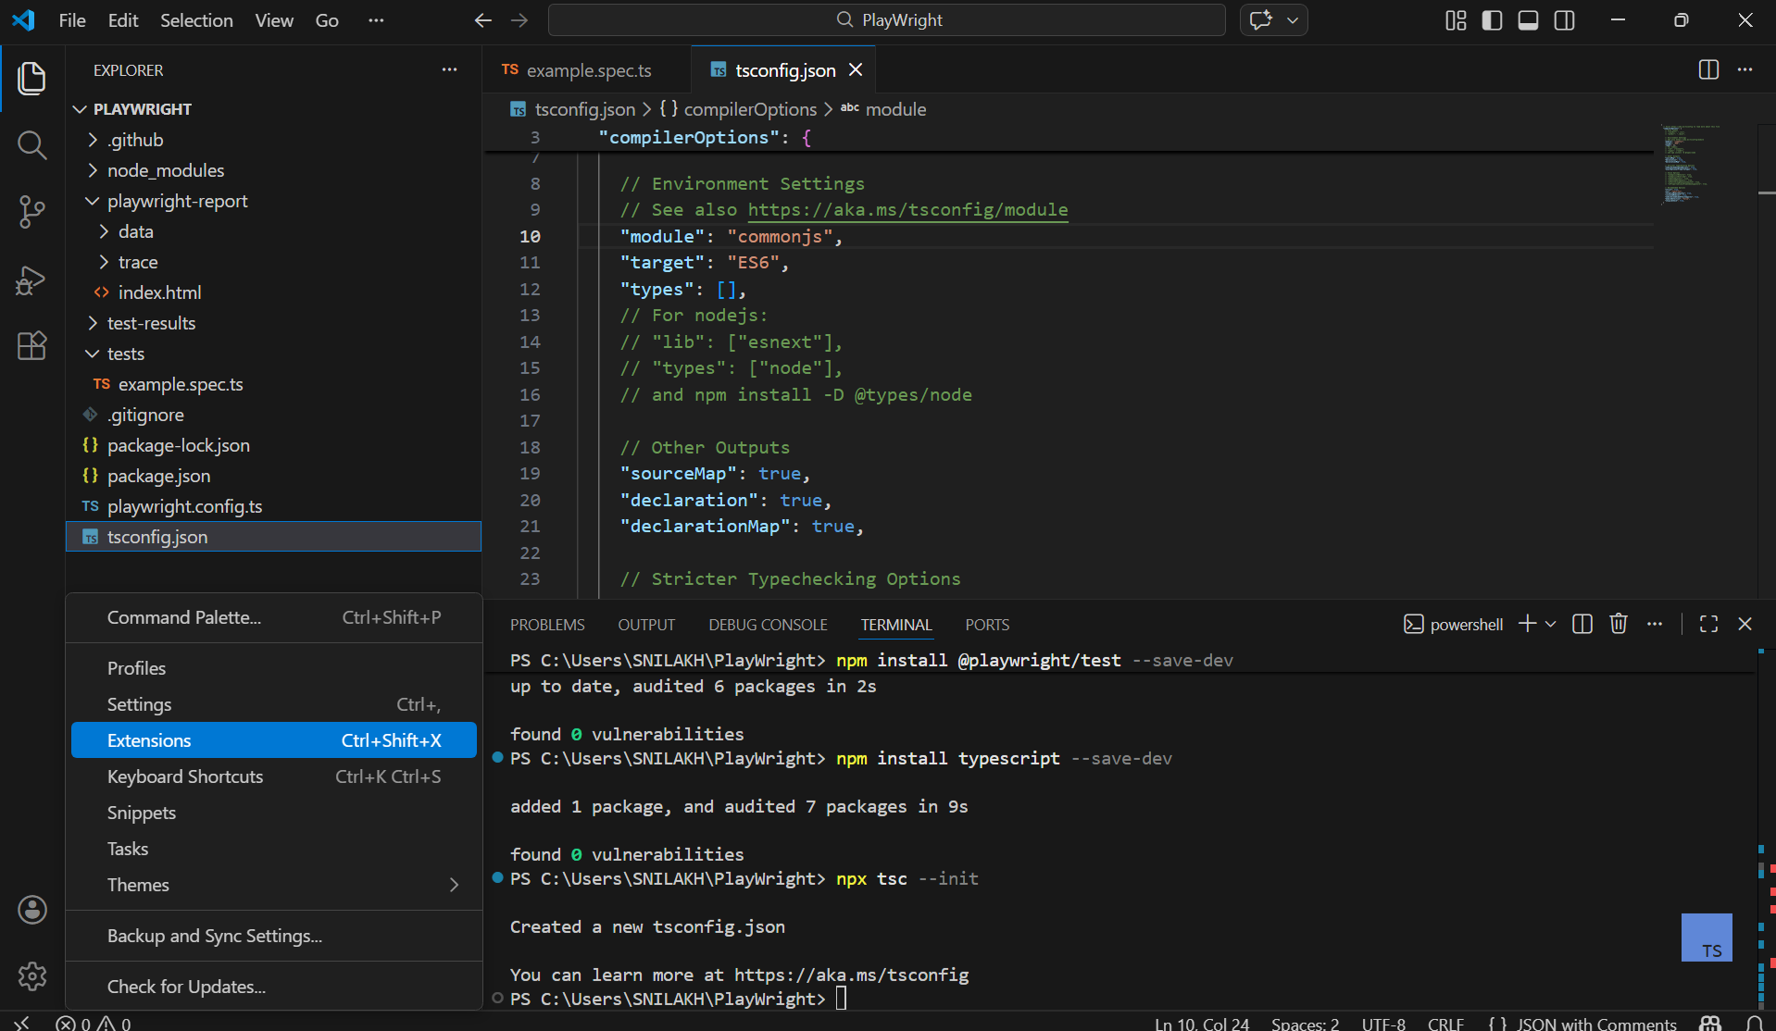

- Start writing tests
First import playwright objects: test, Browser, expect, Page, etc. (same as selenium where we import required dependencies), Import browsers
import {test, expect, Browser, Page} from '@playwright/test'
import {chromium, webkit, firefox} from '@playwright/test'

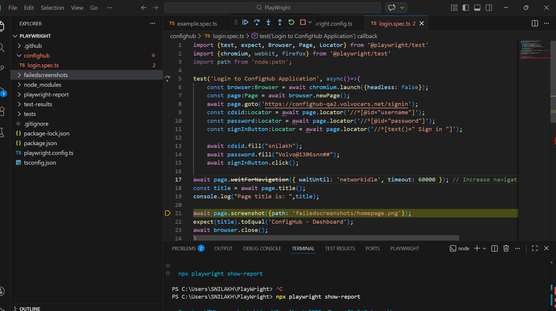

import {test, expect, Browser, Page, Locator} from '@playwright/test'
import {chromium, webkit, firefox} from '@playwright/test'
import path from 'node:path';

test('Login to ConfigHub Application', async()=>{
const browser:Browser = await chromium.launch({headless: false});
const page:Page = await browser.newPage();
await page.goto('https://confighub-qa2.volvocars.net/signin');
const cdsid:Locator = await page.locator('//*[@id="username"]');
const password:Locator = await page.locator('//*[@id="password"]');
const signInButton:Locator = await page.locator('//*[text()=" Sign in "]');

await cdsid.fill("snilakh");
await password.fill("Volvo@1306snn##");
await signInButton.click();

await page.waitForNavigation({ waitUntil: 'networkidle', timeout: 60000 }); // Increase navigation wait timeout
const title = await page.title();
console.log("Page title is: ",title);

await page.screenshot({path: 'failedscreenshots/homepage.png'});
expect(title).toEqual('ConfigHub - Dashboard');
await browser.close();
}
)

